Depth First Search (DFS) algorithm traverses a graph in a depthward motion and uses a stack to remember to get the next vertex to start a search, when a dead end occurs in any iteration.

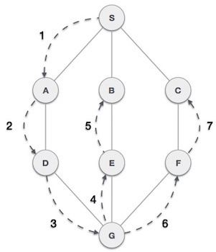

As in the example given above, DFS algorithm traverses from S to A to D to G to E to B first, then to F and lastly to C. It employs the following rules.

* **Rule 1** − Visit the adjacent unvisited vertex. Mark it as visited. Display it. Push it in a stack.
* **Rule 2** − If no adjacent vertex is found, pop up a vertex from the stack. (It will pop up all the vertices from the stack, which do not have adjacent vertices.)
* **Rule 3** − Repeat Rule 1 and Rule 2 until the stack is empty.

|  |  |  |
| --- | --- | --- |
| **Step** | **Traversal** | **Description** |
| 1. | Depth First Search Step One | Initialize the stack. |
| 2. | Depth First Search Step Two | Mark **S** as visited and put it onto the stack. Explore any unvisited adjacent node from **S**. We have three nodes and we can pick any of them. For this example, we shall take the node in an alphabetical order. |
| 3. | Depth First Search Step Three | Mark **A** as visited and put it onto the stack. Explore any unvisited adjacent node from A. Both **S** and **D** are adjacent to **A** but we are concerned for unvisited nodes only. |
| 4. | Depth First Search Step Four | Visit **D** and mark it as visited and put onto the stack. Here, we have **B** and **C** nodes, which are adjacent to **D** and both are unvisited. However, we shall again choose in an alphabetical order. |
| 5. | Depth First Search Step Five | We choose **B**, mark it as visited and put onto the stack. Here **B** does not have any unvisited adjacent node. So, we pop **B** from the stack. |
| 6. | Depth First Search Step Six | We check the stack top for return to the previous node and check if it has any unvisited nodes. Here, we find **D** to be on the top of the stack. |
| 7. | Depth First Search Step Seven | Only unvisited adjacent node is from **D** is **C** now. So we visit **C**, mark it as visited and put it onto the stack. |

As **C** does not have any unvisited adjacent node so we keep popping the stack until we find a node that has an unvisited adjacent node. In this case, there's